October 18, 2022

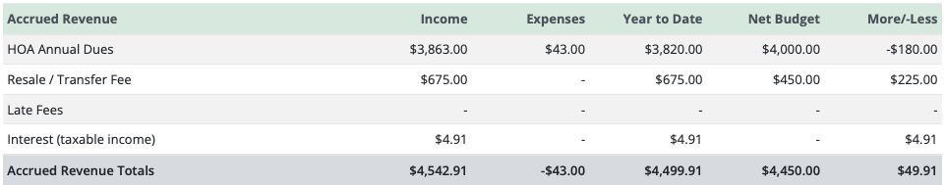

HOA Dues collected for FY 2021 = $40/20
HOA Annual Dues: $43 = overpayment/refund

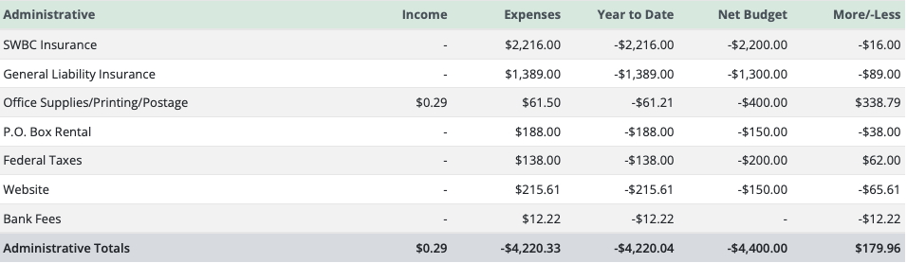

*Office Supplies: $0.29 = debit card offer rebate
*Bank Fees: $12.22 = merchant fee/electronic payment
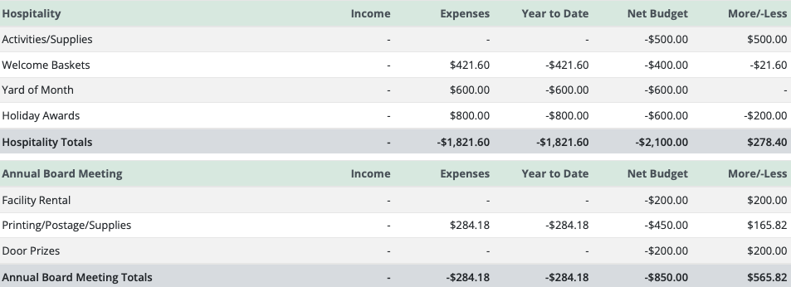

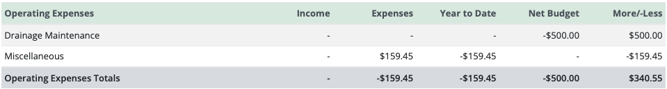

*Miscellaneous: $159.45 = Accounting Software

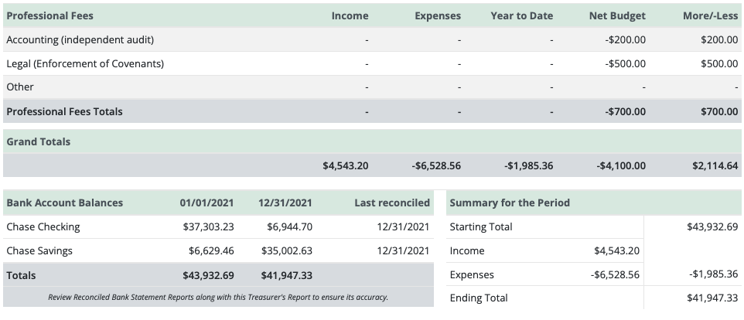

Income – Expenses = $1,985.36

Financial Summary for 2021
Checking account balance: $6,944.70
Saving account balance: $35,002.63
Total: $41,947.33

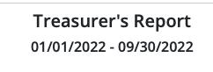
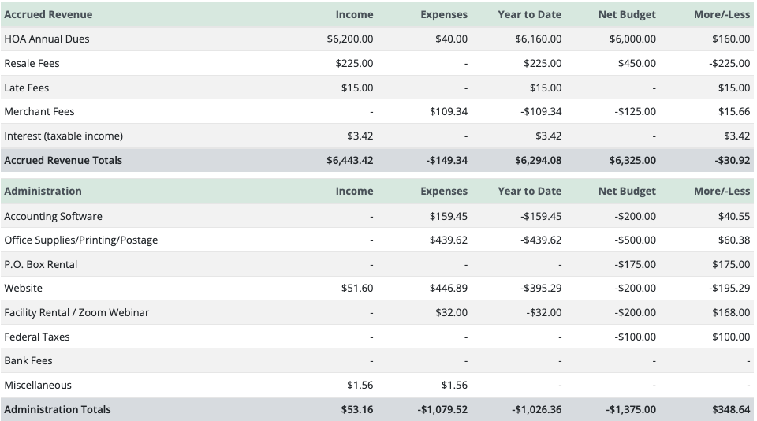

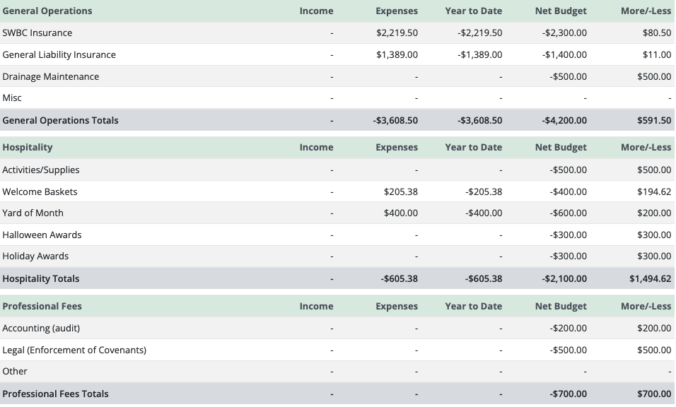

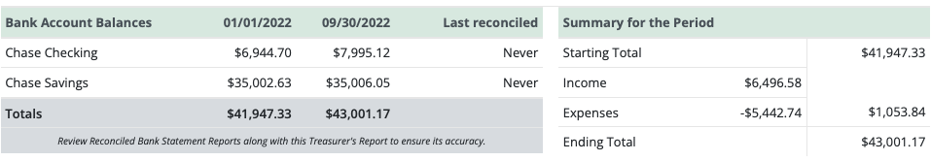

HOA Dues Collected for FY 2022 = $50/40

Income - Expenses = $1,053.84

Projected Expenses:
Halloween & Holiday Awards - $600
P.O. Box Rental - $175

Financial Summary as of September 30, 2022
Checking account balance: $7,995.12
Saving account balance: $35,006.05
Total: $43,001.17

